

Subject:- CSE523 Machine Learning

**Weekly Report 6**

**Section-1**

Submitted to faculty: Prof. Mehul Raval

Date of Submission: 01-04-2023

**Student Details**

| Roll No. | Name of the Student Name of the Program |
| --- | --- |
| AU2040122 | Aditi Vasa Btech CSE |
| AU2040002 | Shrey Somani Btech CSE |
| AU2040196 | Vandan Shah Btech CSE |
| AU2040048 | Ronit Shah Btech CSE |

2020-2021 (Monsoon Semester)

For this week our goal was to try understand our data better by doing field specific EDA. The correlation matrix showed a better relation between the fit and the product size. Hence, we plotted the box and whisker’s plot to understand this relationship better.

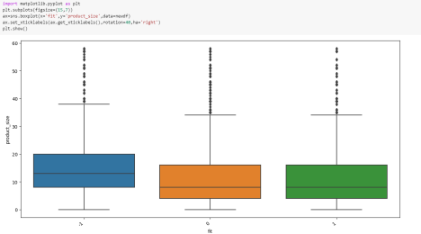

We also found that body type plays a crucial role in deciding the fit of the product. Thus, we plotted histogram to understand how each body type corresponds to the fit of the product. 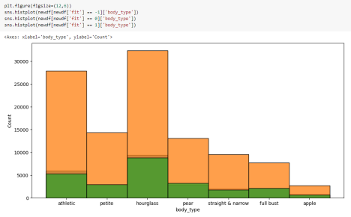

Next our goal was to check the accuracy of our model by applying various machine learning algorithms which we did. We used KNeighbors classifier, Multinomial Naive Baiyes’ approach, Decision Tree, Random Forest, Ada Boost classifier and Gradient Boosting Classifier. Following are the accuracy results for each algorithm.

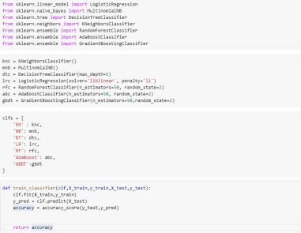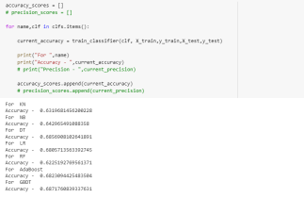

Goals for next week:-

● Define quadratic decision boundaries.

● Understanding where we can improve our accuracy and find the optimal algorithm